Switch

³ 0 0 0 0 0

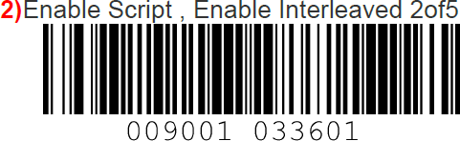

I2OF5_ENABLE : Enable

I2OF5_LENGTH_1 : 02

Switch

